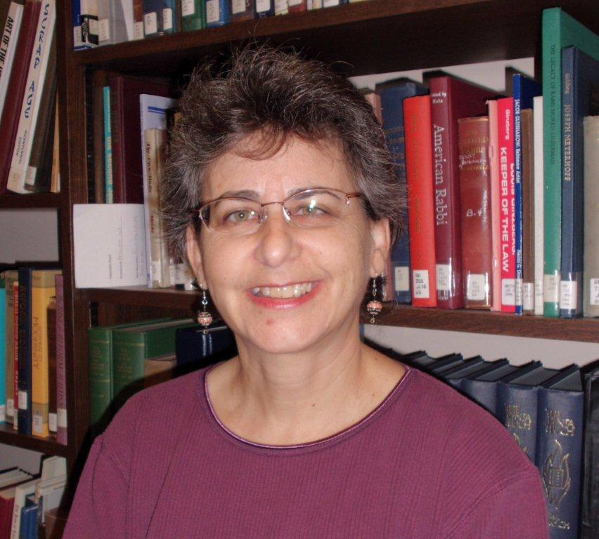
Dr. Deborah R. Weiner
Jewish Museum of
Maryland

“Insiders and Outsiders: Jewish Communities in the Appalachian Coalfields”

Monday, December 5, 2011, 8 pm
W.T. Young Library Auditorium, UK campus
Reception to follow

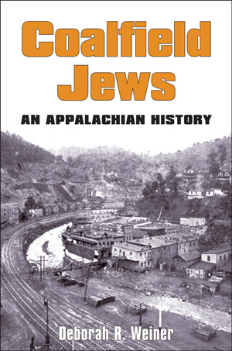

Sponsor: UK Jewish Studies Program, the UK Appalachian Studies Program and the UK Appalachian Center

Free and open to the public. For more information: Jeremy D. Popkin, director, UK Jewish Studies program, popkin@uky.edu

